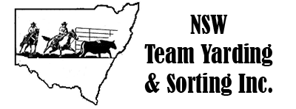

**SORTING RULES:**

1. Minimum of 2 riders for 1 gate sorting and 3 riders for 2 gate sorting.
2. Judge will draw the number and the team will have 5 seconds to cross the line, clock will then start or as the nose of the first horse passes the line.
3. There will be 10 cattle in the pen marked with numbers 0-9 Starting number for each team will be drawn when the team is in the arena.
4. Riders will start with the starting number and continue in numerical order for example – if you are drawn number 3 you must sort from number 3,4,5,6,7,8,9,0,1,2.
5. Cattle are considered sorted when the beast completely crosses the line of the gate
6. If any cattle cross the line of gate out of sequence, the team will be judged a no time.

8. If any cattle already sorted come back through the gate, the team will be judged a no time

9. Teams will have a time limit of 2 minutes, with a warning whistle at 90 seconds

10. Time will stop when the 10th beast stops the clock when it fully crosses through the gate or 1 or both team members show of hand and calls for time

11. Both riders must stop working the cattle to call time and cattle must not be running towards the gate when calling time

12. Horses must not break the line of the gate after the last beast has crossed, or it will be judged no time.

13. The point score system will be:

Points for sorting 10 head is three points plus

1st=5, 2nd=4, 3rd=3, 4th=2, 5th=1

These points will amalgamate for high point end of year.